Explanation of the code

The pathfinding program is implemented by C++ with A\* algorithm.

The main algorithm is included in PathFinding.cpp

The open file function is included in OpenJsonF.cpp

The write file function is included in WriteJsonF.cpp

First, the program is implemented by BFS algorithm but the BFS is slow and has some limitations.

Therefore, I optimize it using inadmissible heuristic.

F(n) = G(n)+H(n)

F(n)=total cost

G(n)=basic cost (cost of moving from start to the node)

H(n)=heuristic cost (heuristic cost of moving from node to destination)

Then we find the node with minimum total cost as current node;

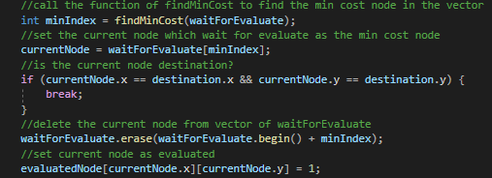

Then compare all basic cost of neighborhoods which already are added into waitlist with current node

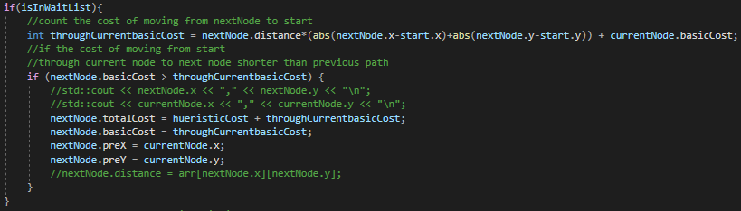

For the neighborhoods are not added into waitlist

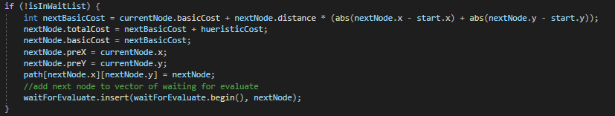

In the end the optimized A\* algorithm was implemented.